**User Manual for UconnJobSearch System**

The UconnJobSearch System is a web-based system opened for both job seekers and companies. People can submit resumes, search for the jobs they want and apply jobs in this system. Also companies can post jobs with specific requirement, and hiring people in this system.

By following this manual you can learn how to register, sign in, and use the UconnJobSearch System.

**For Job seekers:**

1.Register page and Login page

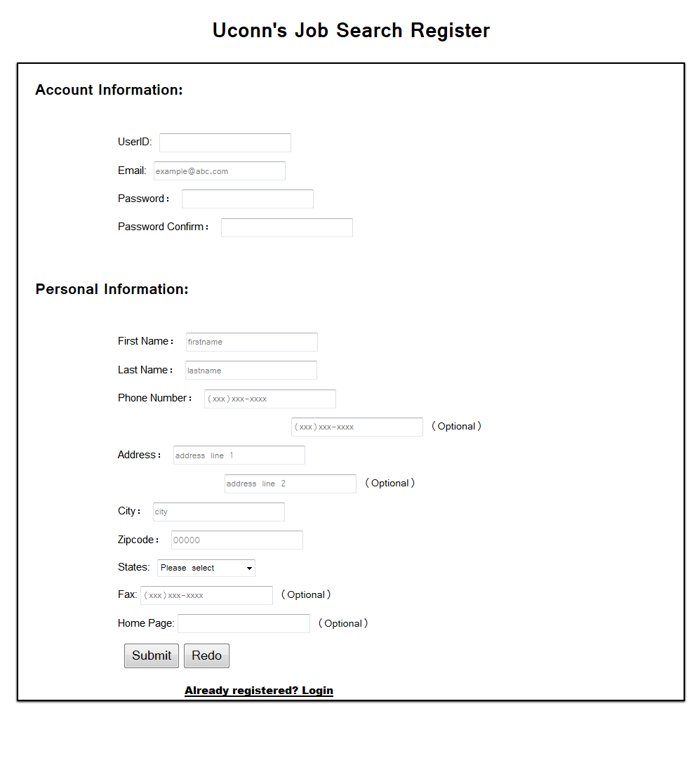

Here is the screenshot of the register page. (for seekers) If you are a seeker. You should create **UserID and password**, provide valid information including **email address, name, phone number and their address**. Some of the information are not necessary as it mentioned. The registration page will notice if the userID is been used, or any necessary information is missing.

The page will tell you once the registration is succeed, and then jump into the main page automatically.

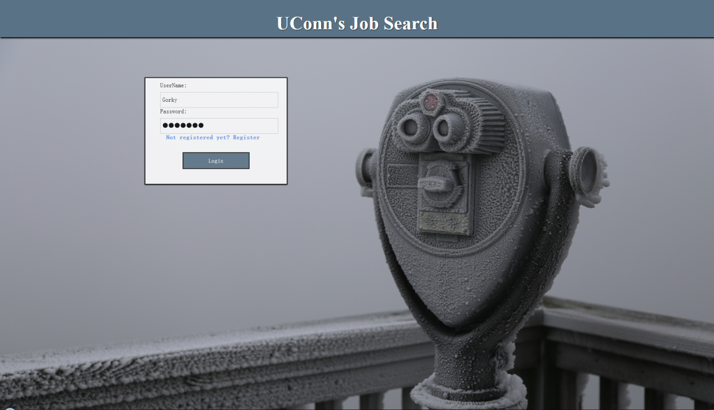

You can go to the login page in sign in once you have your account. If you don't, you can always go to the registration page by clicking **"Not registered yet? Register"**. The registration page has the similar link direct to login page as well. Users can always switch between these two pages.

2. Main page:

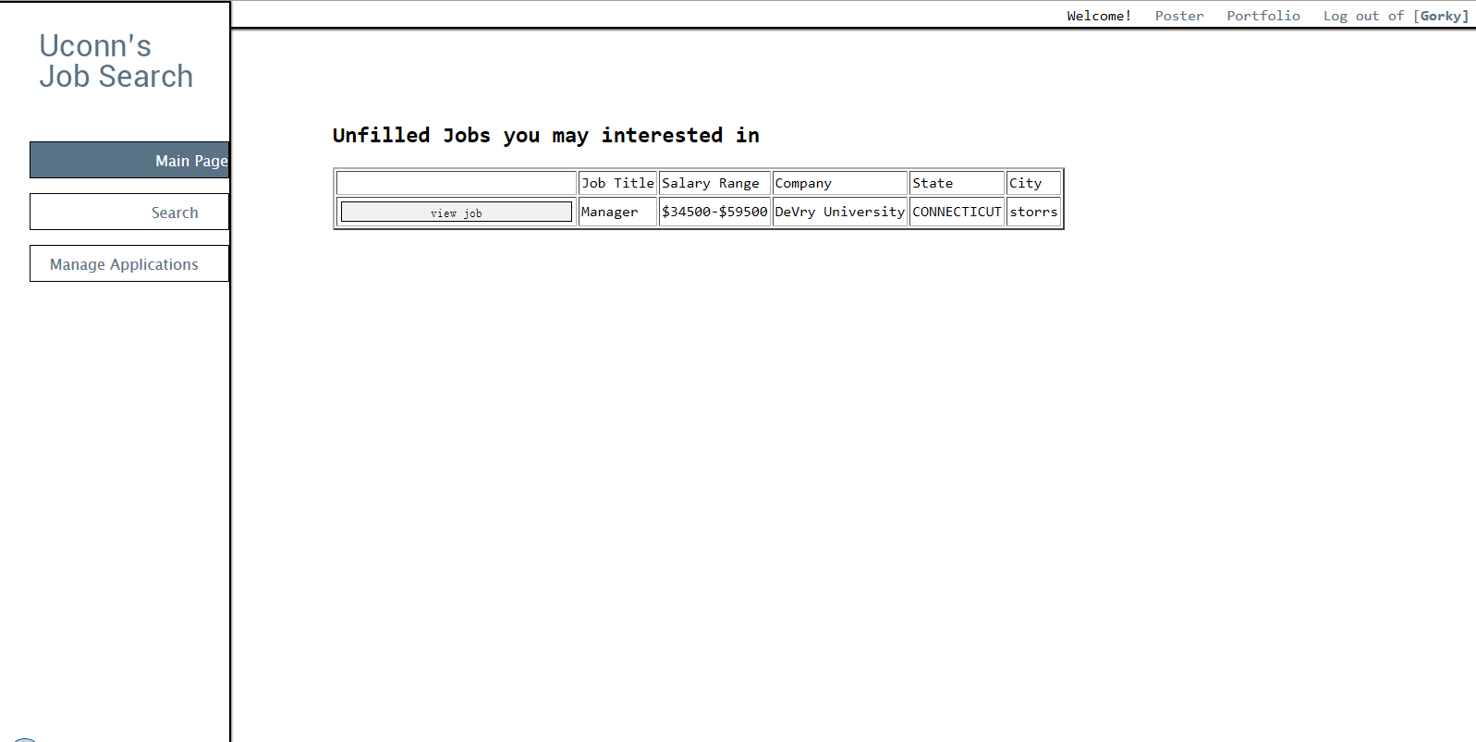

After the you finish their registration (or login). You will be directed to the main page. The main page will show recommend company and jobs for you once you provided at least one resume. The recommendations are based on the skills you selected in your resume. (The method of uploading resume will be mentioned in next step) And you can go to the Search page, Manage Applications page and Portfolio page.

3. Upload resumes

Now click on the **portfolio** on the up right corner of the page so you can go to the profile setting page:

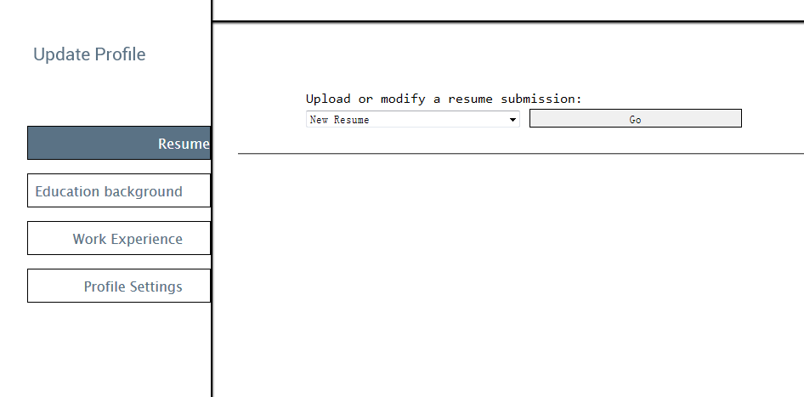

You can upload your resumes, add your education background, work experience and change your registration information right here.

In order to apply for jobs, you need to click **"Go"** shown above and add your first resume:

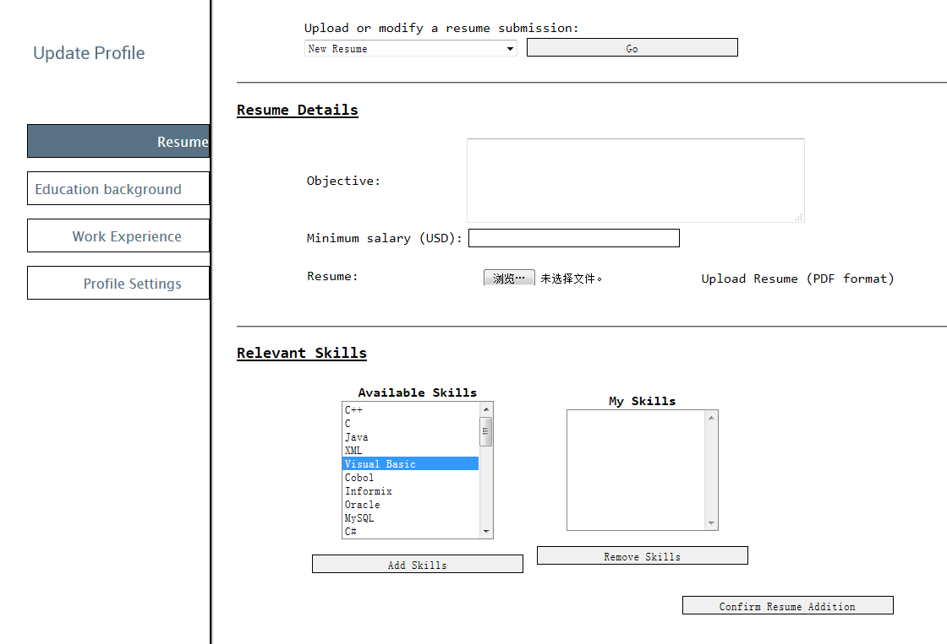

You can input your objective, enter your desired minimum salary and add a PDF format resume.

For Relevant Skills, you can select multiple skills by press and hold "Ctrl" and select skills at once. Then click add skills. You can do the same thing in order to remove any skills.

You can see your uploaded resume after you Confirm Resume Addition.

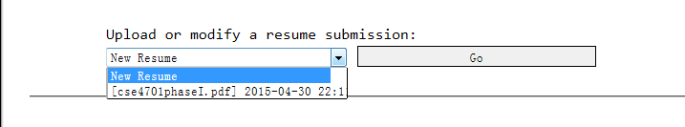

You can always add new resume or edit/delete your submitted resume.

After you submit your first resume, you can apply job in Search page or Main Page by on **"View Job"** in the table:

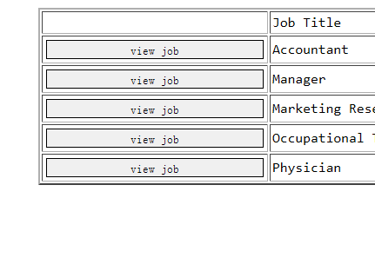

And then apply the job by click on "Apply" with chosen resume:

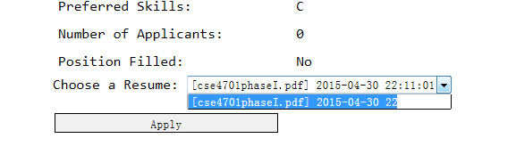

4. Education Background and Work Experience:

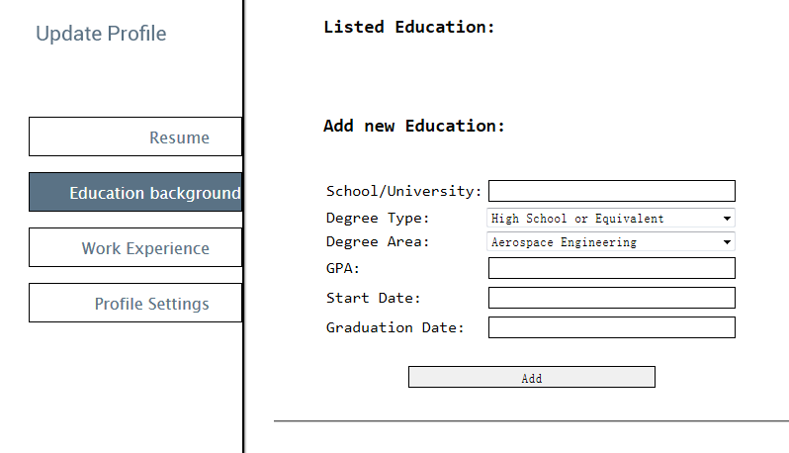

You can **add new Education** in Education Background page.

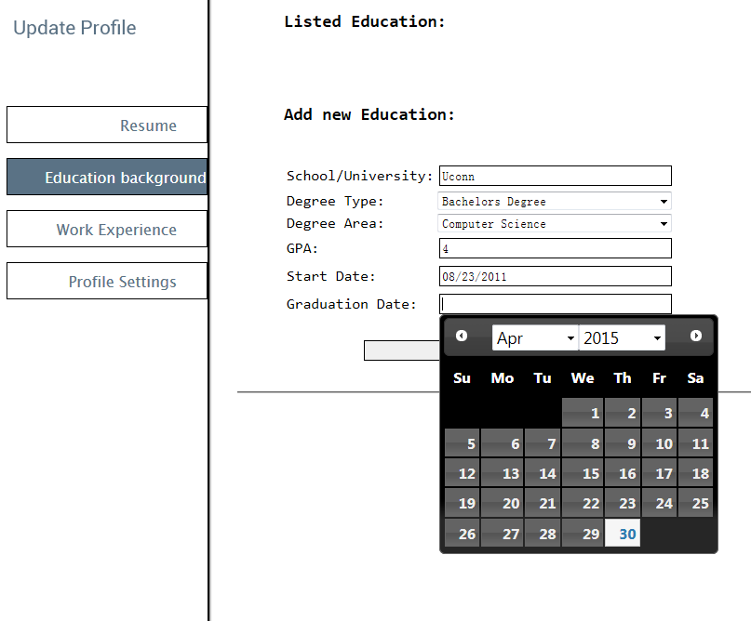

Click **"Apply"** after you input all the information you needed, you can see the added information. You can always add new or edit/delete old information.

The layout is exactly the samein Work Experience page.

4.Profile Setting

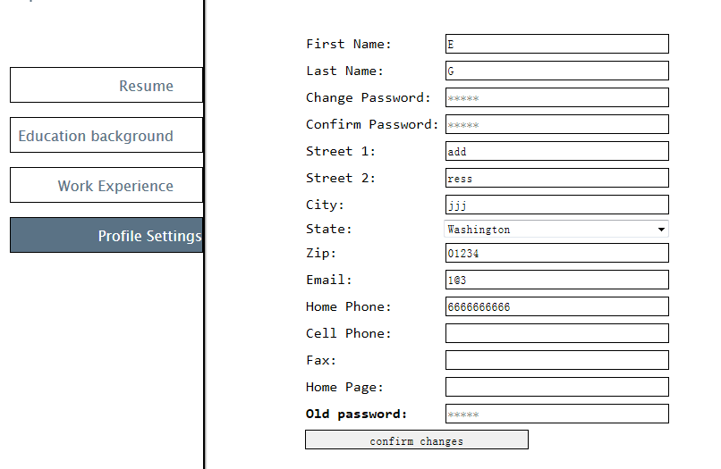

You can change your personal information in the Profile Settings. But you need to re-enter your old password to confirm all the changes.

5. Search Page:

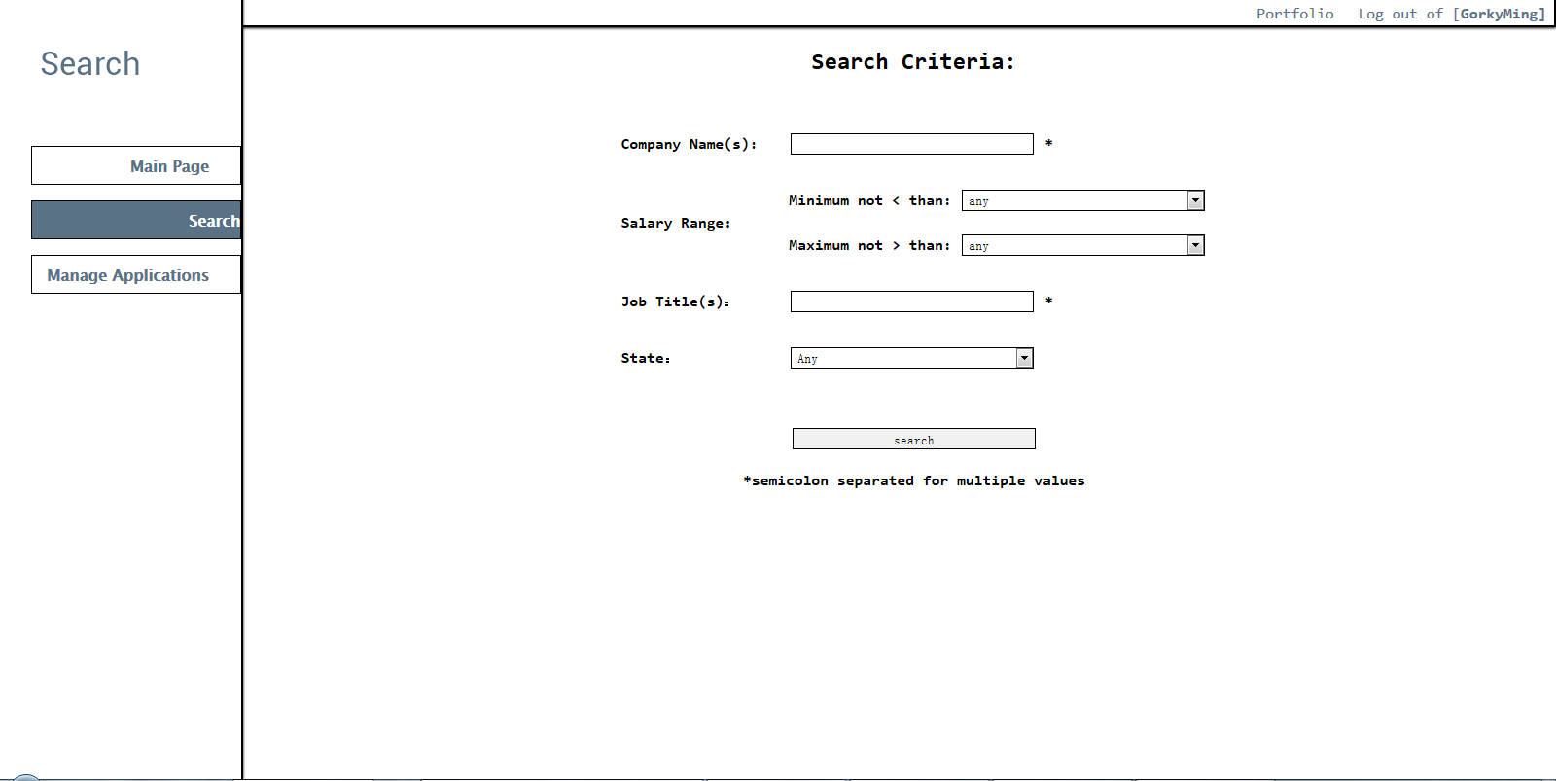

Now you have done all the basic settings, you can go back to the Main Page. Click on Search, you can go to the search page and find the job with your requirement. Here is one search result example:

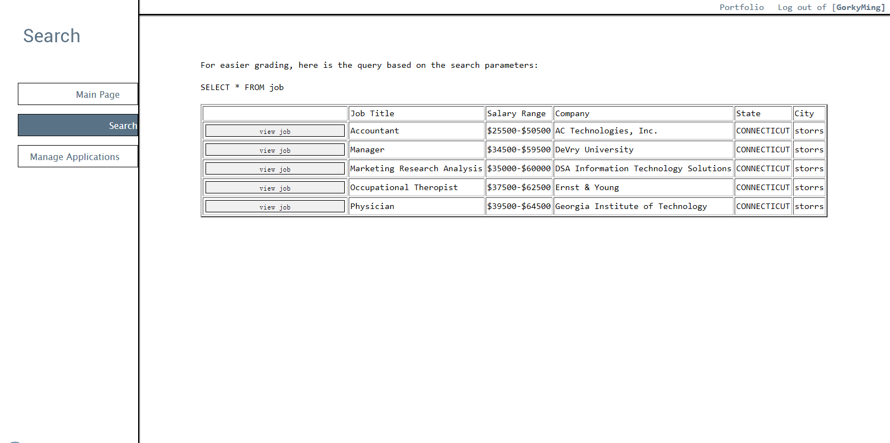

You can check each job's details by click on "View Job" on the first column of the table, and see job details:

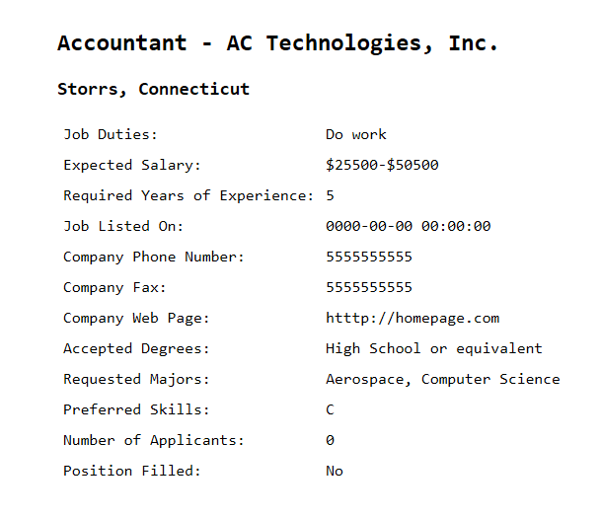

And right now you can apply for these jobs with your resume as mentioned above.

6. Manage Applications:

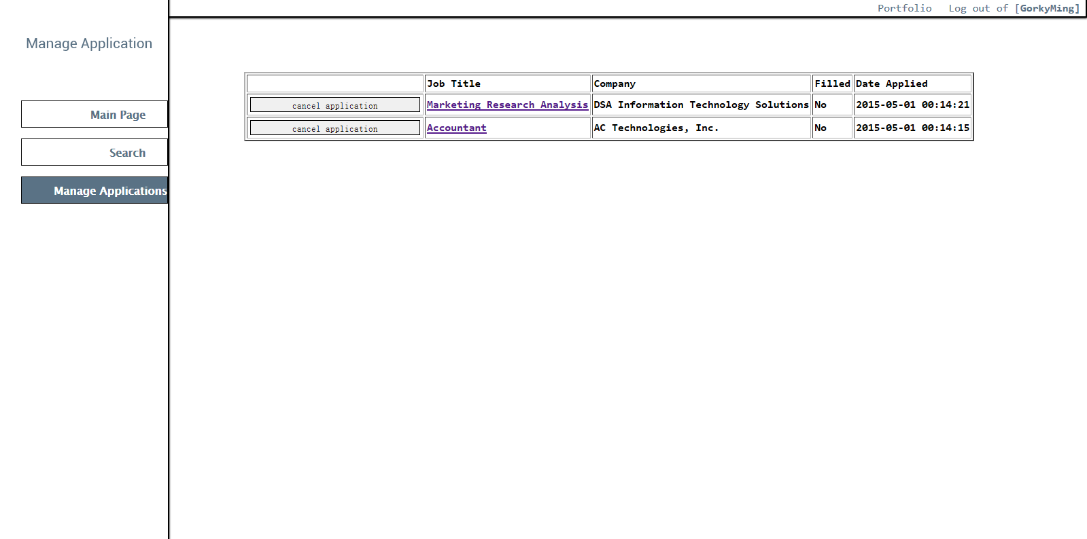

You can check all the jobs you applied in the Manage Applications. You can cancel your application and view each job's details again.

**For Job Posters:**

1.Register page and Login page:

The system for job poster is almost the same. They are sharing the same login system.

For register page. One special register link is provided to posters that allow them to register their information under specific company. One CompanyID input box is added. Poster must enter the given code in CompanyID to process registration.

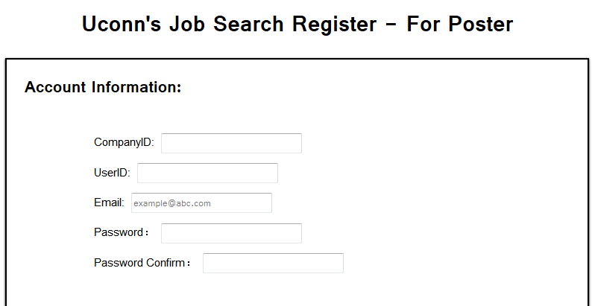

The matched company name will show up once the CompanyID in entered.

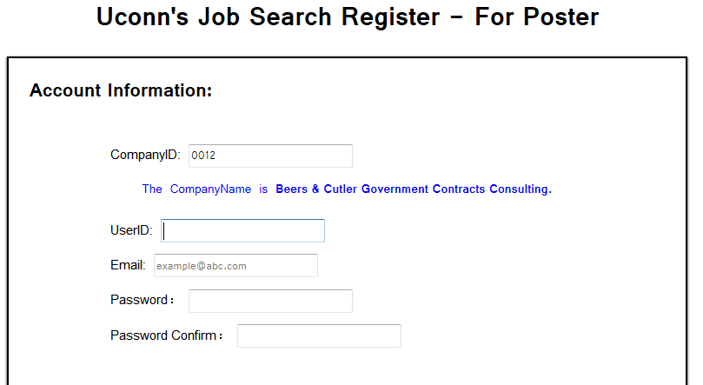

2. Post New Job Page:

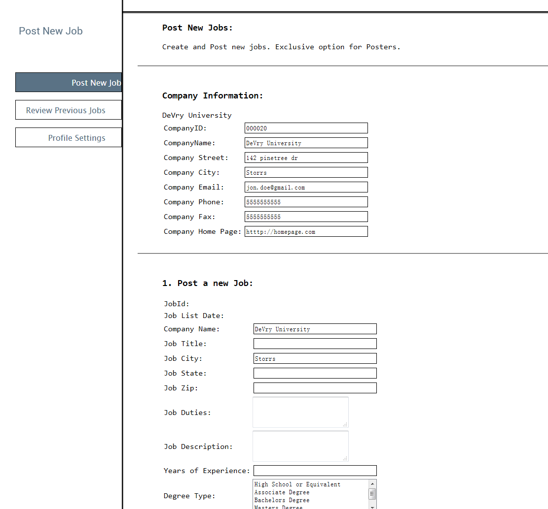

If you are posters, here is what your main page looks like. You can see your company's information here. And post job in **Post a new job**. Then you can go to the page with payment information:

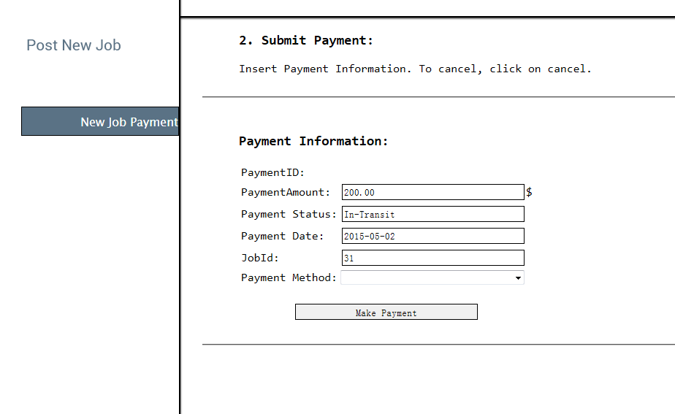

You can select **payment method** including bank, Credit and Online. Each of them will have its information in details.

3. Review Previous Jobs:

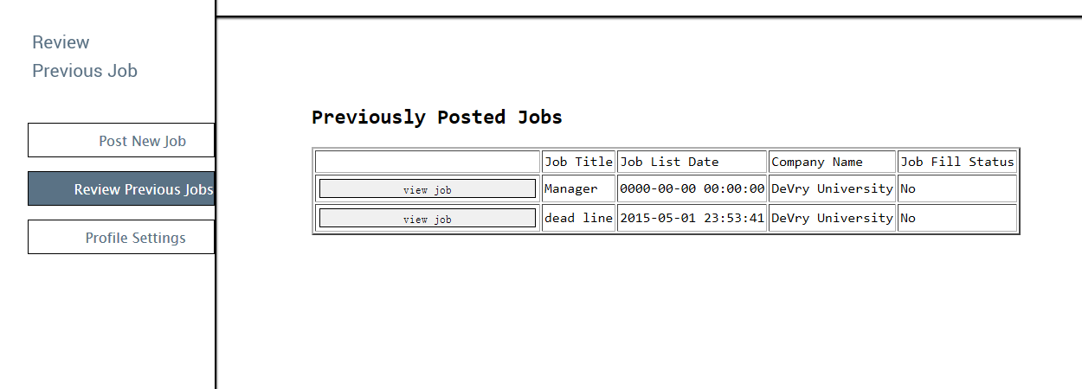

You can review your previously posted jobs in this page. You can check job details and seekers who applied this job by click on **view jobs.**

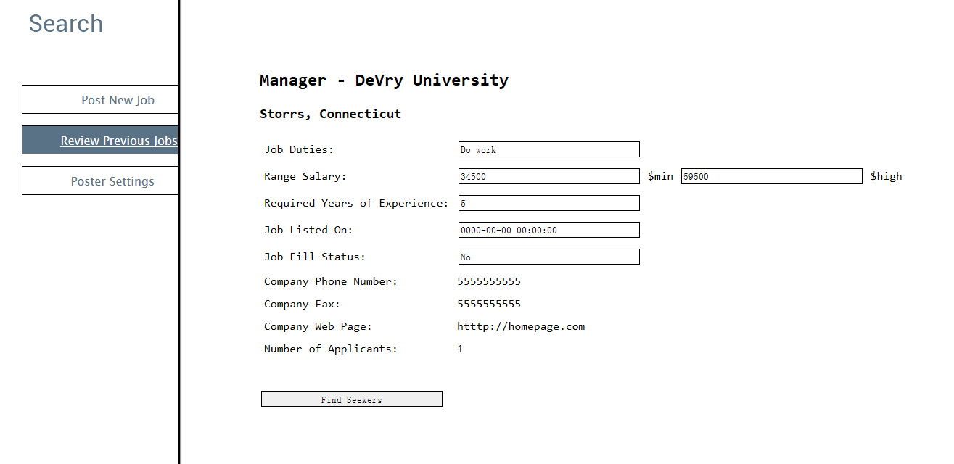

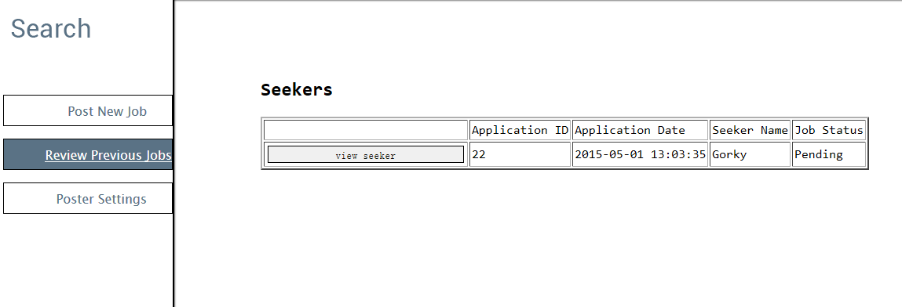

And you can click on View seekers to see each seeker's details.

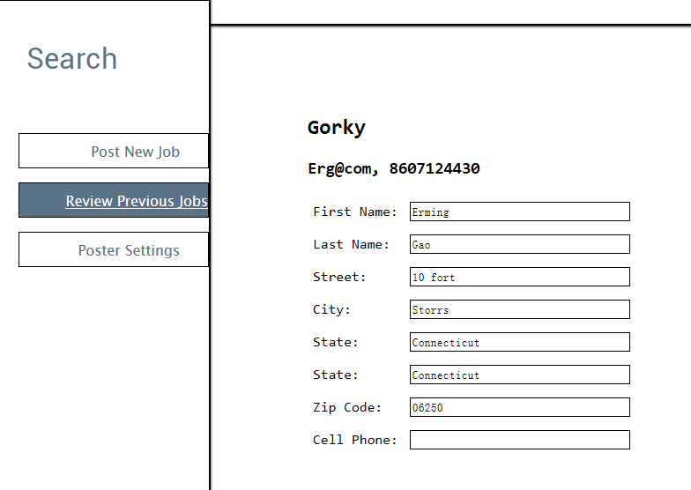

4. Post Settings:

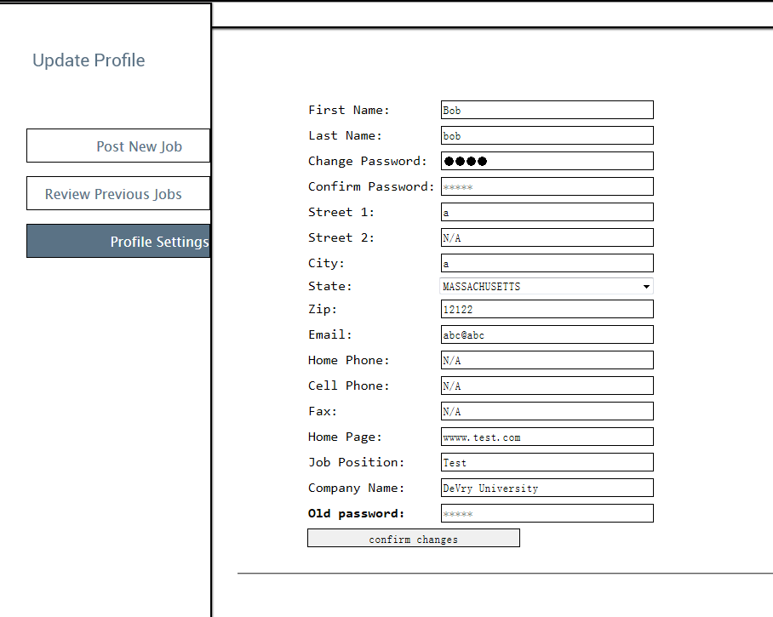

You can change your poster information in this pages. Like the setting for seekers. You need your old password to complete any changes.